Assignment (N+) Day-5(2)
Task-1, 2 & 3:
Click on this

Task-4:
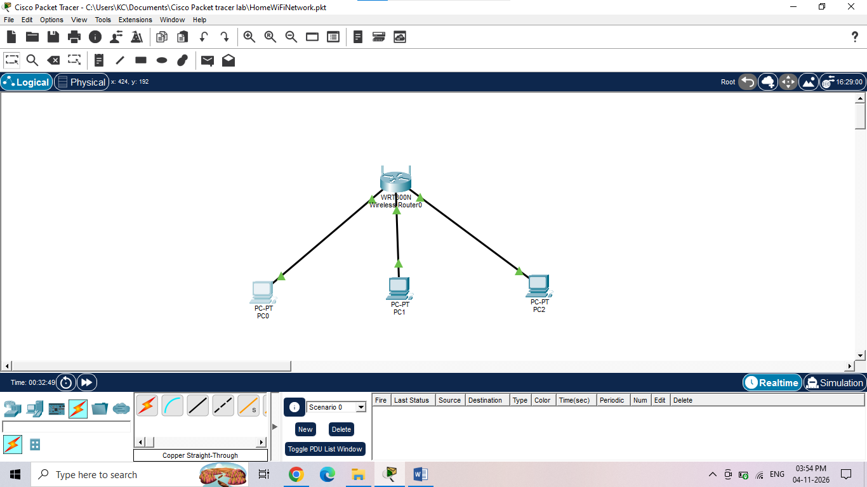

I built this home network in Cisco Packet Tracer by first placing a wireless router and three desktop PCs onto the workspace. To connect them, I used standard copper straight-through cables, plugging each PC directly into the router's local LAN ports.
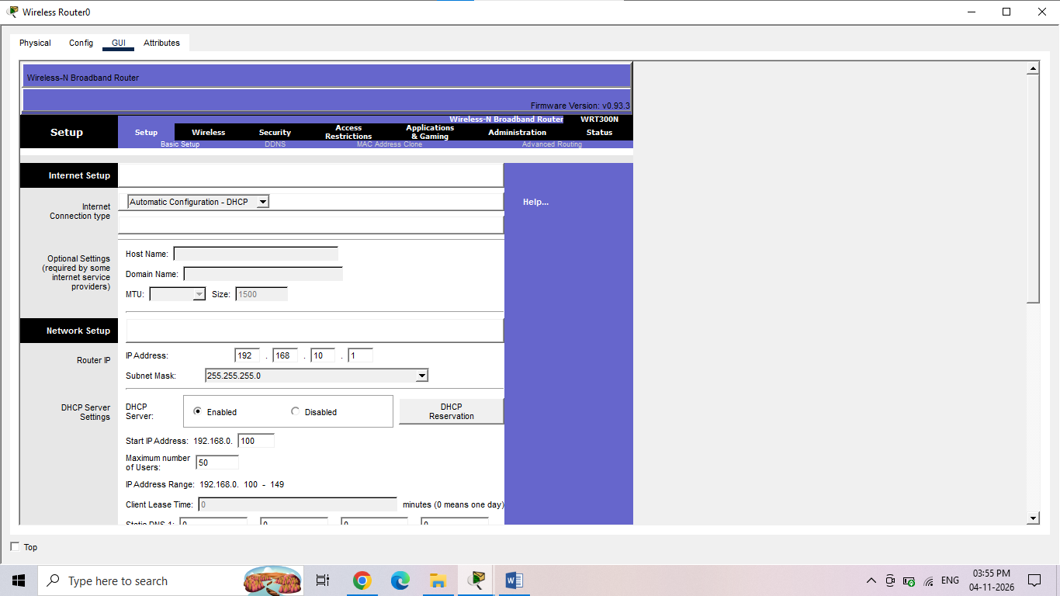
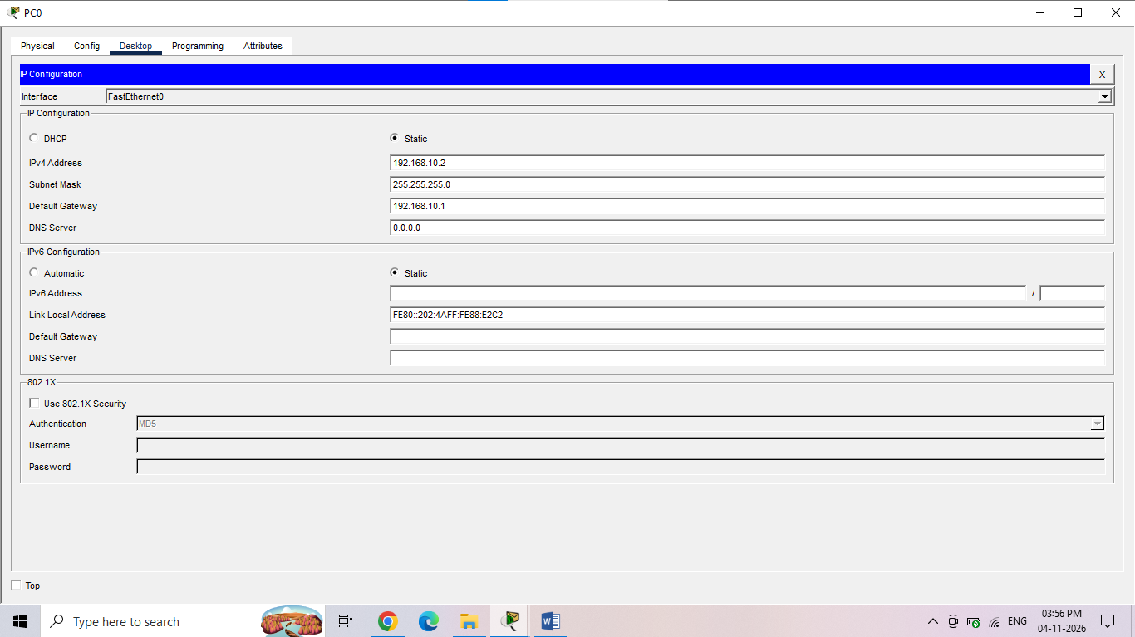
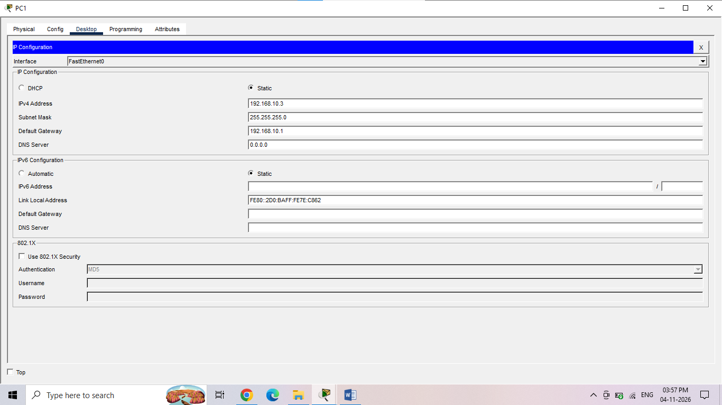
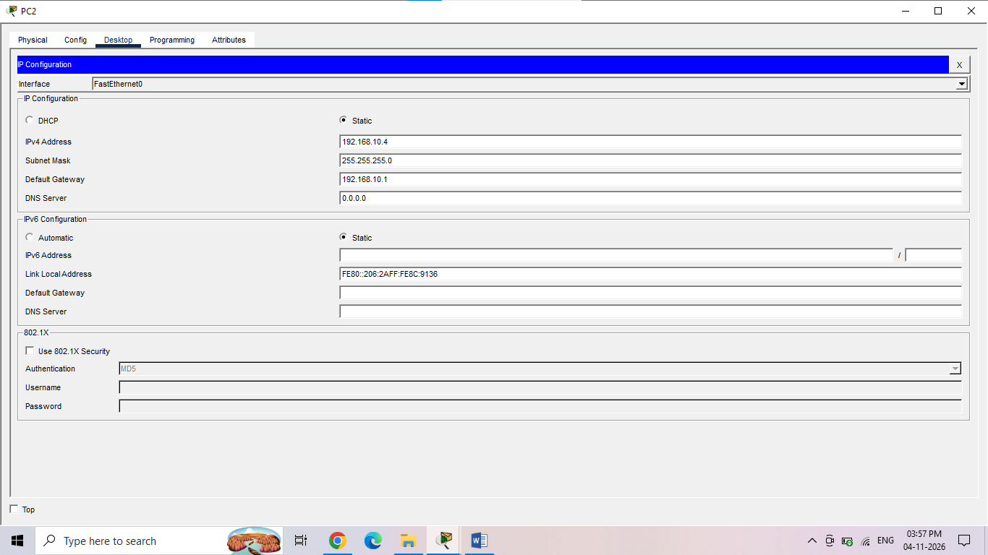
To ensure the devices could communicate, I manually assigned static IP addresses. I configured the router with the address 192.168.10.1 to serve as the default gateway for the network. Then, I opened the desktop settings for each individual PC and assigned them unique, sequential IP addresses on the same subnet: 192.168.10.2, 192.168.10.3, and 192.168.10.4.

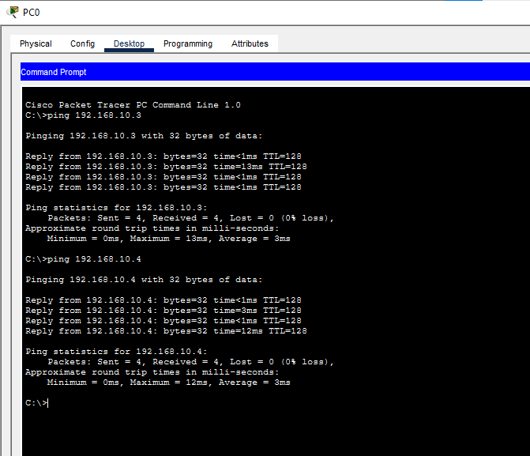
Finally, I verified the network was functioning correctly by using the ping tool. I opened the command prompt on the first PC and sent ping requests to both the router and the other computers. Every ping returned a successful reply, proving that the devices are fully connected and routing traffic properly.

